# CHAPTER ONE

# INTRODUCTION

## 1.1 Background to the study

In many tertiary institutions in the country, students seek a project in a given field of specialty as part of the upper level of their degree programme. Usually, a project can be filled by at most one student, though in some cases a project is suitable for more than one student to work on simultaneously. To give students something of a choice, there should be as wide a range of available projects as possible, and in any case the total number of project places should not be less than the total number of students. Typically, a lecturer will also offer a range of projects, but does not necessarily expect that all will be taken up (Adamu, 2020).

In a Polytechnic environment, conducting research in areas chosen by the students or academic is a prerequisite for meriting a degree or diploma. The Institution oversees that courses are taught and award of degree or diploma given to students who satisfactorily and successfully completed a predetermined course of study that is offered by the institution, and also found worthy in character. Central to all diplomas is a project that students have to undertake and submit in support of their candidature for their National Diploma (ND). Part of this process is the selection and allocation of final year projects involving both academic staff and students. “Whilst the Students Project Allocation (SPA) problem from a resource allocation perspective is not an especially complex one, aspects of the aforementioned methodology are still relevant and can be utilized in a basic form to aid in this project’s success. At a conceptual level, the SPA problem relating to the Department of Computer Science involves three core objects/entities: students, projects and supervisors” (Morgan, 2021).

Web portals are increasing in its everyday use especially in the education sector. It is often seen as a special site designed to provide access to information or to other sites. According to Abdulkareem et al, (2022), a web portal allows users to connect with everything they need, the people needed and provides all the tools that are needed to work with. A web portal has been described by so many researchers with different views or perspectives; however, there is a consensus to the description of web-based portals as evident in Karz et. al, (2017) as a single, personalized interface through which users access all information resources in a secure, consistent and customizable manner. A final year project is a task often engaged in by students as a means of applying the acquired knowledge to achieve set objectives. The process of managing final year projects involves three parties: students, supervisors and the head of department. The head of department (sometimes represented by Project coordinator) assigns a lecturer to supervise each student.

Over time, it has been discovered that students are becoming very lazy and are no more original in the project carried out to qualify them for the degree awarded. From the little findings carried out, it was discovered that since students are allocated to different supervisors, a project carried out by a student in a particular year with certain supervisor could be picked up by another student in another year and replicate to another supervisor within the same department without the supervisor’s knowledge (Folasade, 2021). The reason for these is often characterized with a manual process which involve a paper-pen method of keeping past projects. Keeping track of such paper-pen projects by supervisors could be tasking, repetitive and tiring, there is the need to design and develop a user-friendly, easily accessible and robust system for users (basically supervisors) to ameliorate this problem. This research develops a web based final year student’s project management system.

The proposed system when implemented will eradicate repetition of projects carried out by students; encourage ingenuity from students since they are aware that all supervisors have access to all existing projects. The application will also provide soft copy of existing projects and a database for previous projects topics accessible only by supervisors. Future suggestions made by previous projects can be taken up if such projects are to be embarked upon so as to know the additional contributions being made by the student (Jumok, 2022).

Suyome (2022) stated that in many tertiary institutions in the country, students seek a project in a given field of specialty as part of the upper level of their degree program. Usually, a project can be filled by at most one student, though in some cases a project is suitable for more than one student to work on simultaneously. To give students something of a choice, there should be as wide a range of available projects as possible, and in any case the total number of project places should not be less than the total number of students. Typically, a lecturer will also offer a range of projects, but does not necessarily expect that all will be taken up.

Each student has preferences over the available projects that he/she finds acceptable, whilst a lecturer will normally have preferences over the students that he/she is willing to supervise. There may also be upper bounds on the number of students that can be assigned to a particular project, and the number of students that a given lecturer is willing to supervise. In this Project we consider the ways of allocating student project in Computer Science Department, Federal Polytechnic, Mubi.

## 1.2 Problem Statement

The traditional method of assigning and managing student projects in institutions like Federal Polytechnic, Mubi, is largely manual and prone to several inefficiencies. Project allocation is often done through physical documentation or verbal agreements between students and supervisors, with minimal tracking or centralized monitoring. This makes it difficult to detect and prevent the duplication of project topics, especially in large departments with high student turnover. Currently, there is no automated system in place to verify if a topic has already been used in previous sessions, leading to the risk of multiple students unknowingly working on similar or identical projects. This not only compromises academic originality but also undermines the quality of research outputs.

Additionally, the lack of a centralized project database means that project records are scattered across different departments or are stored only in physical files. This causes challenges in accessing, verifying, and updating project information. The absence of a digital system also limits transparency, making it difficult for supervisors or coordinators to monitor project distribution and progress effectively. Furthermore, without a robust backup or digital storage mechanism, these projects are vulnerable to loss through misplacement, damage, or natural disasters like fire. The current system also imposes geographical restrictions, preventing remote access to project records by staff or external stakeholders. Therefore, there is a clear need for a computerized Student Project Allocation and Verification System that can streamline project distribution, prevent topic duplication, enhance data accessibility, and ensure the integrity of academic research records.

1.3 Aim and Objectives

The aim of this project is to design a student project allocation and verification system for monitoring duplication of projects. The specific objectives are as follows:

1. To develop a system that will verify the availability or non-availability of a project topic to avoid duplication.
2. To create a database management system (DBMS) which store research project and provides security for the stored data.
3. To provide quick and efficient means of retrieving students’ research/projects material through a search system.
4. To Implement the proposed system using HTML/CSS, PHP and MySQL.

## 1.4 Significance of the Study

The project study will aid the process of retrieving past students’ project and create a secure means of storing the projects electronically for easy accessibility.

This project will create a secured system for verifying project topics in Computer Science Department to avoid duplication of research projects and also create a platform where a research can view topics already done by other students in order to guide him or her on the choice of project topic selection.

The study will also serve as a reference material for researchers who intend to conduct similar research or improve on it.

## 1.5 Scope of the Study

The research will center on the design and implementation of Student Project Allocation and Management system for the Computer Science Department, Federal Polytechnic, Mubi, Adamawa state. The system will also provide a search module for users to search for research topics or materials.

## 1.6 Definition of Some Operational Terms

**Algorithm**: The step by step methods and procedures that must be followed to achieve a goal (Merriam-Webster, 2021).

**Allocation**: the action or process of allocating or sharing out something (Butler, 2022).

**Database**: This is an organized collection of data, generally stored and accessed electronically from a computer system (Ben, 2016).

**Duplication**: the action or process of making the exact copy of something (Butler, 2022).

**Monitoring**: To observe and check the progress or quality of (something) over a period of time (Merriam Webster, 2021).

**Project**: is a project or academic task that must be accomplished individually by every undergraduate student to obtain the attributions to graduate (Butler, 2022).

**System**: A collection of different entities working together to function as one (Merriam-Webster, 2021).

**Verification**: the process of establishing the truth, accuracy, or validity of something (Butler, 2022).

# CHAPTER TWO

# LITERATURE REVIEW

## 2.1 Introduction

This chapter reviewed literature on information systems, which was published in textbooks, journals, the internet and others, and is relevant to the problem under study. And it also involved a review of previous studies in relation to the research topic of analyzing, developing and implementing a Project allocation and Verification System.

## 2.2 Project Management Systems in Academic Institutions

Project management systems have gained significant attention in educational institutions, enabling efficient allocation and management of student projects. Several studies have focused on developing and evaluating project management systems in different academic domains.

A student project is a work that a student creates as part of a tertiary/high school, undergraduate, or graduate school program. Student project are long academic documents that students write after they research a particular subject in depth. Therefore, student projects are usually assigned once per course, per semester, or only once as part of an academic program (David, 2022)

There are many different ways in which a lecturer or academic program will use student project assignments. Therefore, students may have to write project for different reasons, depending on their level of study and academic institution. For example, (Dye, 2023) “A secondary school student may have to write a year-end student project as part of an overall high school program. Usually, the project will be graded by a supervisor, but all students in a particular grade might have to work on a project in order to pass a grade. A junior project is a good example of this sort of assignment”. An undergraduate student project might be a large assignment that a student has to create as part of an academic course. In such a case, the undergraduate student project might be similar to a term paper. For an undergraduate student project, the student should research a particular subject in depth in order to create the paper. This paper would usually account for the majority of a semester grade. A student may also have to create a project for each course that he or she is taking.

A graduate student project has its own definition and set of requirements. In most cases, a graduate project is, according to Valter (2024), one paper that a student works on for a large portion of the graduate program, especially in his or her final months of the program. This project requires a huge amount of research and may even be ground-breaking for a particular industry. Students will then have to defend their student project in front of a panel of judges that are familiar with the subject matter in the project. These panel members may ask the student questions related to his or her research or to the project itself. This sort of graduate project is also often called a graduate school dissertation.

While there are many definitions and uses for student project, the basic writing elements are the same. Therefore, students should always research a particular subject and write the academic document with an introduction, body, conclusion, resources, and appendices (David, 2022).

Li *et al.* (2019), proposed a project management system that integrated project proposal submission, evaluation, and allocation features. The system employed a weighted scoring method to assess project proposals and allocate projects based on student preferences and project requirements. The study reported improved transparency, fairness, and efficiency in project allocation.

Chen *et al.* (2021), developed a web-based project management platform that facilitated seamless collaboration between students and faculty members. The system encompassed project proposal submission, allocation, progress tracking, and evaluation, enhancing student engagement and project outcomes.

Dianiška *et al*. (2022), which focused on the design and implementation of a project management system for engineering education. The system incorporated features such as project proposal submission, evaluation, allocation, and progress tracking. The study reported that the system improved project management efficiency and facilitated effective communication between students and faculty members.

In the field of computer science education, Wang *et al.* (2021), developed a project management system specifically designed for computer science departments. The system integrated functionalities for project proposal submission, allocation, progress tracking, and collaboration. The researchers found that the system enhanced project outcomes, promoted student engagement, and facilitated effective mentorship.

Furthermore, the study by Simsek *et al.* (2020), examined the impact of a project management system in a business school setting. The system incorporated features such as project proposal submission, evaluation, allocation, and progress tracking. The results indicated that the system improved project management efficiency, enhanced student satisfaction, and fostered effective collaboration among students and faculty members.

Additionally, the adoption of project management systems aligns with the growing emphasis on project-based learning in education. Such systems provide a structured framework for managing projects, enabling students to apply theoretical knowledge in practical scenarios, develop critical thinking skills, and enhance their problem-solving abilities (Li et al., 2019).

## 2.3 Project Allocation Algorithms

Project allocation algorithms play a crucial role in ensuring fair and efficient assignment of projects to students. Researchers have explored various algorithms and techniques to optimize the project allocation process. One notable approach is the use of data mining techniques to analyze student profiles and project attributes. Bala *et al.* (2020) utilized data mining algorithms to match student preferences, skills, and availability with project requirements. The study reported improved project allocations and higher satisfaction among students.

Another approach is the application of optimization algorithms such as genetic algorithms or linear programming. For example, Dasgupta *et al.* (2023), proposed a genetic algorithm-based project allocation method that considered multiple criteria, including student preferences, project requirements, and resource constraints. The algorithm yielded improved project assignments, considering both student satisfaction and resource utilization.

One approach that has gained attention is the use of machine learning algorithms and data mining techniques to improve project allocation outcomes. For instance, Liu *et al.* (2021), proposed a project allocation model based on a random forest algorithm. The model considered various factors such as student preferences, skills, project requirements, and resource availability. The study demonstrated that the algorithm-based approach resulted in more accurate and fair project assignments, enhancing student satisfaction and engagement.

Furthermore, deep learning techniques have been employed to enhance project allocation processes. A study by Xu *et al.* (2022), utilized a deep neural network model to match student profiles and project attributes, considering factors such as skills, preferences, and project requirements. The deep learning-based approach resulted in more precise project allocations and improved resource utilization within the department.

In addition to machine learning and deep learning techniques, optimization algorithms have been utilized to optimize the project allocation process. Chen *et al.* (2020), proposed a genetic algorithm-based approach for project allocation that aimed to maximize student preferences while satisfying project requirements and resource constraints. The study reported improved project assignments, considering both student satisfaction and efficient resource utilization.

Moreover, some studies have explored the integration of multiple criteria in project allocation algorithms. For instance, Zhu *et al.* (2020), developed a multi-objective optimization algorithm that considered criteria such as student preferences, project requirements, resource availability, and fairness. The algorithm generated project allocations that aimed to maximize student satisfaction while ensuring balanced resource allocation within the department.

Furthermore, the utilization of data-driven algorithms in project allocation aligns with the growing emphasis on personalized and student-centric approaches in education. These algorithms take into account individual student preferences, skills, and project requirements, resulting in more tailored and meaningful project assignments (Liu *et al.,* 2021).

## 2.4 Benefits of Project Management Systems in Academic Institutions

The adoption of project management systems in academic institutions has demonstrated several benefits for students, faculty members, and the overall learning environment. Project management systems enhance transparency and fairness by providing clear criteria for project allocation and ensuring that student preferences and skills are considered (Li *et al*., 2019). This transparency fosters student satisfaction, engagement, and motivation.

One significant benefit is improved transparency and fairness in project allocation. Project management systems provide clear criteria and processes for project assignment, ensuring that student preferences, skills, and project requirements are considered (Li *et al*., 2019). This transparency fosters a sense of fairness among students, reduces biases, and enhances their satisfaction with the project allocation process.

Furthermore, project management systems enhance communication and collaboration between students and faculty members. Wang *et al.* (2021), reported that their project management system facilitated seamless collaboration by providing a centralized platform for project-related interactions. Students and faculty members could easily communicate, share project updates, and seek feedback, fostering effective mentorship and support throughout the project lifecycle.

Efficient resource allocation is another notable benefit of project management systems. These systems consider the availability of resources such as facilities, equipment, and mentors, ensuring optimal utilization and allocation (Chen *et al*., 2021). This leads to improved resource planning, reduced conflicts, and enhanced project outcomes.

Real-time monitoring and progress tracking features provided by project management systems enable students and faculty members to track project milestones, identify bottlenecks, and address issues promptly (Simsek *et al.,* 2020). Such monitoring capabilities enhance accountability, enable timely interventions, and contribute to the successful completion of projects.

Additionally, project management systems support data-driven decision-making. By collecting and analyzing project-related data, these systems provide valuable insights into project progress, resource utilization, and student performance. This data-driven approach enables evidence-based decision-making, facilitating continuous improvement and informed project management strategies (Li *et al*., 2019).

Moreover, the adoption of project management systems aligns with the growing demand for project-based learning approaches. These systems provide a structured framework for managing projects, enabling students to apply theoretical knowledge to practical scenarios, develop critical thinking skills, and enhance their problem-solving abilities (Guzdial, 2024). This experiential learning approach fosters deeper understanding, engagement, and transferable skills development. Efficient resource allocation is another significant advantage of project management system. By considering resource availability, such as facilities, equipment, and mentors, the systems optimize resource utilization and ensure a conducive environment for project completion (Chen *et al*., 2021).

## 2.5 Management Information System

Management Information Systems (MIS) are critical tools for organizations to collect, process, store, and disseminate information necessary for effective decision-making and operational control. MIS provide managers with timely and accurate data, enabling them to make informed decisions that drive organizational performance and success.

Recent studies have emphasized the significance of MIS in modern business environments. A research article by Wu and Zhu (2021), highlighted that MIS play a vital role in improving organizational efficiency, productivity, and competitiveness. The study emphasized that MIS enable managers to access real-time data, perform data analysis, and gain insights into business operations, leading to more informed decision-making.

One of the key functions of MIS is data collection and processing. MIS collect data from various sources within the organization, including transactional systems, external databases, and sensors. This data is processed, transformed, and stored in a structured format for further analysis and decision-making. A study by Turban *et al.* (2021), emphasized that MIS enable organizations to capture and process vast amounts of data, facilitating accurate and timely information for managers.

Moreover, MIS provide tools for data analysis and reporting. These systems employ various analytical techniques, such as data mining, statistical analysis, and predictive modelling, to identify patterns, trends, and relationships within the data. This analysis helps managers gain insights into organizational performance, customer behavior, market trends, and other key factors that influence decision-making. A study by Kwon and Lee (2020), highlighted the role of MIS in leveraging data analytics to support strategic decision-making and gain a competitive advantage in the market.

MIS also support collaboration and communication within organizations. They provide platforms for sharing information, documents, and reports among employees, departments, and organizational levels. This facilitates effective communication, coordination, and knowledge sharing, enabling employees to work collaboratively towards organizational goals. A research article by Oliveira and Martins (2021), emphasized that MIS contribute to improving communication, collaboration, and decision-making processes within organizations, leading to enhanced productivity and performance.

## 2.6 Record Management System

Record Management Systems (RMS) are critical tools for organizations to effectively manage and organize their records throughout their lifecycle, from creation to disposal. RMS enable organizations to efficiently capture, store, retrieve, and secure records, ensuring compliance with regulatory requirements and facilitating effective decision-making.

Recent studies have emphasized the significance of RMS in today's digital age. A research article by Liu et al. (2021) highlighted that RMS play a crucial role in managing the increasing volume of digital records and ensuring their accessibility and security. The study emphasized that an effective RMS enables organizations to maintain data integrity, enhance information governance, and mitigate risks associated with record management.

One of the key functions of RMS is record capture and creation. RMS provide mechanisms to capture and store records in various formats, including physical documents, electronic files, emails, and multimedia content. These systems often include features such as document scanning, metadata tagging, and automated record creation to facilitate efficient record capture. A study by Rahman *et al.* (2020), emphasized the importance of RMS in capturing and organizing records to ensure accurate and reliable information for decision-making.

Moreover, RMS offer tools for record storage and retrieval. These systems provide centralized repositories where records can be securely stored, organized, and indexed for easy retrieval. Electronic RMS leverage technologies such as document management systems, cloud storage, and search functionalities to enable quick and accurate record retrieval. A research article by Singhal *et al.* (2021), highlighted the role of RMS in ensuring the availability and accessibility of records when needed, contributing to improved organizational efficiency and productivity.

RMS also support records retention and disposal processes. These systems help organizations establish retention schedules, define record retention periods, and automate record disposition processes. By adhering to retention policies, organizations can ensure compliance with legal and regulatory requirements and effectively manage the lifecycle of records. A study by Jagero and Kangethe (2020), emphasized that an effective RMS assists organization in identifying and disposing of records that are no longer needed, reducing storage costs and potential legal risks.

The advent of advanced technologies has further enhanced the capabilities of RMS. Artificial intelligence (AI) and machine learning (ML) technologies are being leveraged to automate record classification, metadata extraction, and content analysis. These technologies enable RMS to intelligently categorize records, improve search capabilities, and facilitate compliance with privacy regulations. A research article by Mathe *et al.* (2021), discussed the potential of AI and ML in transforming record management processes, reducing manual effort, and enhancing the accuracy of record classification.

## 2.7 Database Management System

Database Management Systems (DBMS) are essential tools for storing, organizing, managing, and retrieving data efficiently. DBMS provide a structured approach to store and retrieve data, ensuring data integrity, security, and scalability for organizations.

Recent studies have highlighted the significance of DBMS in various domains. A research article by Ramakrishnan and Gehrke (2020), emphasized that DBMS are crucial for managing the increasing volumes of data generated in today's digital world. The study highlighted that DBMS enable organizations to handle diverse data types, ensure data consistency, and support complex data queries.

One of the key functions of DBMS is data storage and organization. DBMS provide a structured framework for storing data in tables, defining relationships between tables, and enforcing data integrity through constraints. These systems often employ relational models, such as the widely-used SQL (Structured Query Language), to manage data in a tabular format. A study by Elmasri and Navathe (2019), emphasized that DBMS enable efficient data storage, normalization, and indexing to optimize data retrieval performance.

Moreover, DBMS offer tools for data retrieval and manipulation. These systems allow users to query the database using SQL or other query languages to retrieve specific data based on specified criteria. DBMS also support complex operations such as joining multiple tables, filtering data, and aggregating results. A research article by Rizvi *et al*. (2021), highlighted the role of DBMS in enabling efficient and accurate data retrieval, facilitating decision-making and analysis.

DBMS also provide mechanisms for data security and access control. These systems enable organizations to define user roles and permissions, ensuring that only authorized users can access and modify the data. DBMS also offer features such as data encryption, backup, and recovery to protect against data breaches and system failures. A study by Motahari-Nezhad *et al.* (2021), emphasized the importance of DBMS in ensuring data privacy, integrity, and availability, particularly in the context of sensitive and regulated data.

The advent of advanced technologies has further enhanced the capabilities of DBMS. Distributed DBMS enable data storage and processing across multiple servers, providing scalability, fault tolerance, and high availability. NoSQL (Not Only SQL) DBMS have emerged as alternatives to traditional relational DBMS, offering flexible data models and scalability for handling large volumes of unstructured and semi-structured data. A research article by Ghazal *et al.* (2020), discussed the benefits and challenges of NoSQL DBMS in big data environments.

## 2.8 Related Work

A related study by Leung *et al.* (2021) developed a final year project management system for Information Technology programs and tried to implement an online platform that facilitates the final year projects process. The system among others was to help project supervisors track the progress of the projects in form of group projects using project management tools (Leung, 2022). The project is web-based although it is only accessible within local area network covered by the router broadcast.

Abdulkareem *et al.* (2023), in their work "Design and Development of a University Portal for the Management of Final Year Undergraduate Projects" designed a portal-based system used for the automation of the processes associated with the management of final year projects in the department of Electrical and Information department Engineering, Covenant University, Nigeria. The processes start from the allocation of project supervisors to students down to the final clearance of the student after the project defense. ASP.NET was used to create the web server, C-sharp language (C#), Microsoft SQL server 2005 as the back-end (Abdulkareem, 2021)

According to Abubakar *et al.* (2022), there is the need to inculcate research skills into students by introducing research elements in the school teaching curriculum at all levels. The study developed a prototype web-based supervision management system. The prototype of their work consists of three modules, namely user profile, project monitoring (of software development and report writing) and appointment setting (Abubakar, 2022). The case study of this study which is the Federal Polytechnic, Ilaro already introduced research methodology both at the National Diploma and Higher National Diploma levels in the student curriculum to drive home the knowledge required in carrying out proper research. He introduced a system using Microsoft Visual C++ and MySQL database system to prevent repetitive project topics evaluation. The system is design only for the Computer department of the School as its limitation. Final year students are required to undertake research in their specific domain of study and develop software prototype as partial requirement for their final year project.

Romdhani *et al.* (2021), carried out a statistical analysis on ‘Student project performance management system for effective final year and dissertation project supervision. The study was tailored towards integrated and collaborative online supervision system for final year and dissertation projects. They proposed an e-supervision system under development that can link the communication and the process among all involved parties in final year project supervision. This system does not directly isolate duplication or reputations in project topics rather a supervisor can psychologically determine topics relationships to only students under his custody.

It is a common phenomenon in higher institutions of learning that final year student’s projects are often managed in paper-pen system where most of these students lay their hands on already completed projects, and present them to their supervisors. Duplication of projects words for words, year in, year out. Laziness on the part of the students replicating work without originality. This trend contributed to the poor technological skills of graduates produced in many institutions today which invariably also impact on the society at large.

## 2.9 Summary of the Review

In this research, we focused on the peculiarity experienced presently in our institution and others concerning duplicating the same projects year in year out by lazy students who are not ready to work. Also, project students are distributed among several supervisors who may not be aware that certain projects had been supervised by specific supervisor in a particular year and the same is being brought up to him verbatim. The proposed system improves these aforementioned problems. The system will be made available to all project supervisors to ensure that projects are not repeated and in cases where a project has to be repeated, there must be some novel contribution to knowledge by the students.

**CHAPTER THREE**

# SYSTEM ANALYSIS AND DESIGN

## 3.1 Introduction

This chapter contains the system design and analysis of the proposed system, the disadvantages of the existing system, the advantages of the proposed system over the existing system, the requirements (Hardware and Software), the design and the system architecture.

**3.2 Disadvantages of the Existing System**

It is cleared that replication and plagiarisms of research works has dominated the current system of student projects in various academics and below are some of these problems.

1. Presently student project allocation and verification is done manually which is very difficult to avoid duplication of topics.
2. It involves a very tough and time consuming process.
3. Paperwork can take up a significant amount of space, and the need of space will increase as the number of the document increases.

**3.3 Advantages of the Proposed System**

Computerized database system has been for decades managing relational records in an organized and defined manner. This has raised to the need to automate the method of managing student projects in an academic environment.

1. Allocation and verification of student projects would be very easy. When the proposed system is designed.
2. It will save time.
3. Accurate, efficient and reliable result would be obtained when the new system is designed.

## 3.4 Software Development Model

The development of the Student Project Allocation and Verification System will follow the Waterfall Model, ensuring a structured and systematic approach to implementation. The system will progress through distinct phases, illustrated in Figure 3.1, to ensure accuracy and reliability in event management.

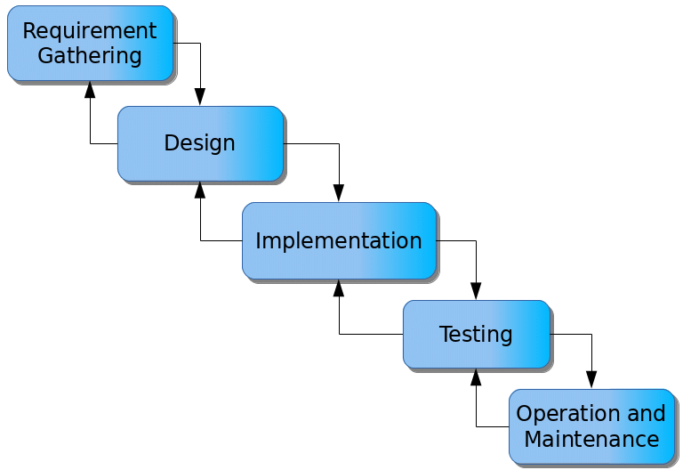

Figure 3.1: Waterfall model

**Requirements Gathering**

1. Project stakeholders, including students, staff, and event organizers, will be engaged to collect comprehensive information about event planning, scheduling, and management needs.
2. Specific requirements for user roles, event categories, and notification methods will be documented.
3. All gathered requirements will be meticulously recorded for reference throughout the system development process.

**System Design**

1. The system architecture will be developed, outlining the decision-making process and workflow for event management.
2. A database schema will be designed to store and retrieve event details, user profiles, and notifications efficiently.
3. A user-friendly interface will be created to allow organizers to add events, students to register for events, and administrators to oversee activities.

**Implementation**

1. The system design specifications will be translated into a functional web-based or mobile application, adhering to best practices in event management.
2. A notification system will be implemented to send real-time updates via email, SMS, or in-app alerts.
3. The database structure will be developed to ensure secure and efficient storage of event data and user information.

**Testing**

1. Unit testing will be conducted to validate the accuracy and functionality of individual system components.
2. Integration testing will be performed to verify the smooth interaction between various modules and databases.
3. System testing will be carried out to assess the overall performance, reliability, and user experience of the system.

**Maintenance**

1. Identified issues or system bugs will be promptly addressed based on user feedback and performance reviews.
2. Regular updates will be implemented to incorporate new features and improve system efficiency.
3. Future enhancements will be planned to ensure the system remains relevant to evolving campus event management needs.

## 3.5 Methods of Data Collection

There are two main sources of data collection in carrying out this study, information was basically obtained from the two sources which are primary and secondary sources.

**Primary Source:** Primary source of data that will be used in this study will be personal interview and observation.

**Secondary Source:** The secondary data used in the study will be obtained from magazines, Journal, newspapers, library source and most of the information from the library research has been covered in my literature review in the previous chapter of this project.

## 3.6 System Design

## 3.6.1 Algorithm Diagrams

**3.6.1.1 Use Case Diagram**

A use case diagram at its simplest is a representation of a user’s interaction with the system and depicting the specifications of a use case. A use case diagram shows the system and the various ways that they interact with the sub system.

Login

Add student(s)

Add Project Topic

Search topic

View Report

Logout

Admin

Figure 3.2: Use Case Diagram

## 3.6.2 System Architecture

Database MySQL

Apache Server

Administrator

Figure 3.3: System Architecture

## 3.6.3 Database Tables/Queries Structures

**Table 3.1: Add Project Table**

| **Name** | **Type** | **Extra** |
| --- | --- | --- |
| id Primary | int(11) | AUTO_INCREMENT |
| project_name | varchar(255) |  |
| project_case | varchar(255) |  |
| project_level | varchar(50) |  |
| allocation | tinyint(1) |  |

**Table 3.2: Project topic table**

| **Name** | **Type** | **Extra** |
| --- | --- | --- |
| id Primary | int(11) | AUTO_INCREMENT |
| topic | varchar(100) |  |
| abstract | varchar(1000) |  |
| authors | varchar(100) |  |
| Level | varchar(64) |  |
| year | date |  |

**Table 3.3: Add Student table**

| **Name** | **Type** | **Extra** |
| --- | --- | --- |
| id Primary | int(11) | AUTO_INCREMENT |
| name | varchar(255) |  |
| department | varchar(50) |  |
| level | varchar(50) |  |
| matric | varchar(50) |  |
| date | date |  |
| project_id | int(11) |  |

## 3.6.4 Entity Relationship Modelling

**STUDENT**

Id No.

Name

Department

Level

Matric No.

Date

Project id

**SUBMITTED TOPICS**

Id No.

Topic

Reg_num

Level:

status

**PROJECTS**

Id No

Project_topic

Case study

Level

allocation

Figure 3.4: Entity Relationship Modelling

## 3.6.5 Database Entity Relationship Diagram

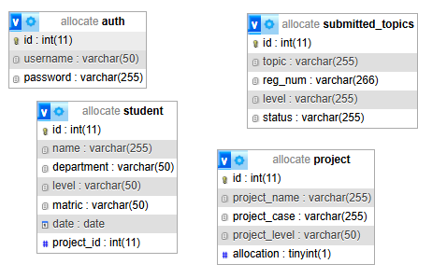

Figure 3.5: Database Entity Relationship Diagram

## 3.6.6 The Input and Output Design

**LOGIN**

**LOGIN**

Figure 3.6: Log in form

**SEARCH PROJECT**

**SEARCH**

Project title:

Figure 3.7: Search Project

Project title:

Abstract

Author(s)

Year

Level

**add TOPIC**

Figure 3.8: Add Project Topic

**Add Student**

**SUBMIT**

Student Name

Student Reg. No.

Department

Level

Figure 3.5: Add Student Form

Figure 3.9: Add Student Form

**Add Student**

**SUBMIT**

UMAR ADAMU

ST/CS/ND/23/044

COMPUTER SCIENCE

ND 2

Figure 3.5: Add Student Form

Figure 3.10: Add Student Form Output

## 3.7 System Requirement Specification

## 3.7.1 Hardware Requirements

The software to be designed will need the following hardware for an effective operation.

1. A system running on intel, P(R) duo core with higher processor
2. The-Random Access Memory (RAM) should be at least 512MB.
3. At least 20-GB hard disk.
4. A colored monitor.
5. A mobile device.

## 3.7.2 Software Requirements

The software requirements include:

1. A window 7 or higher version of operating system.
2. XAMP or WAMP for Database
3. PHP
4. MySQL
5. Web browser

**3.7.3 Personnel Requirements**

The system will be design in such a way that it is user friendly in other to be understood and used by anyone with basic computer knowledge.

# CHAPTER FOUR

# RESULTS AND DISCUSSION

## 4.1 Introduction

The new system is designed using PHP and MySQL programming language for easy records inserting and updating. This system will help in managing and easily retrieving of information from the system for management purposes.

## 4.2 Results

**4.2.1 Welcome interface**

This is the first interface that users will encounter upon accessing the system. It provides an overview of the project, displaying the project title, student information, and the supervisor’s details.

**STUDENT PROJECT ALLOCATION AND VERIFICATION SYSTEM FOR MONITORING DUPLICATION**

**BY**

**ST/CS/ND/23/026 AND ST/CS/ND/23/098**

**SUPERVISED BY: MALLAM**

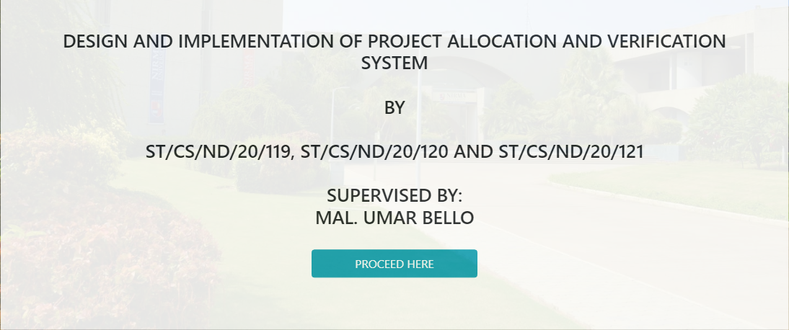

Figure 4.1: Welcome Interface

**4.2.2 Login interface**

This interface is designed for authentication purposes, allowing only authorized users, such as administrators or project coordinators, to gain access. Users must enter their credentials, such as a username and password, to log into the system before performing any operations related to project allocation and verification.

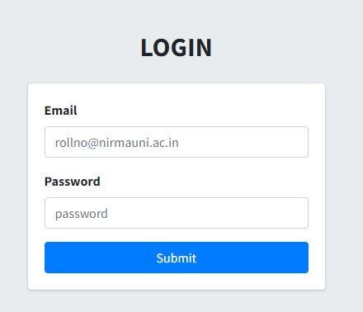

Figure 4.2: Login page interface

**4.2.3 Add Student Interface**

This section enables the project coordinator or administrator to register new students into the system. The interface captures essential student details, such as name, matriculation number, department, and level, ensuring that only registered students can submit project topics for allocation and verification.

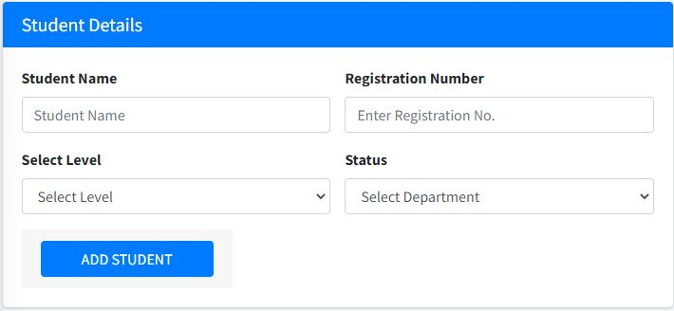

Figure 4.3: Add Student interface

**4.2.4 Register Project Topic Interface**

This interface allows project coordinators to input and register project topics proposed by students. It ensures that each student is assigned a unique project title and facilitates the verification process to prevent duplication of topics.

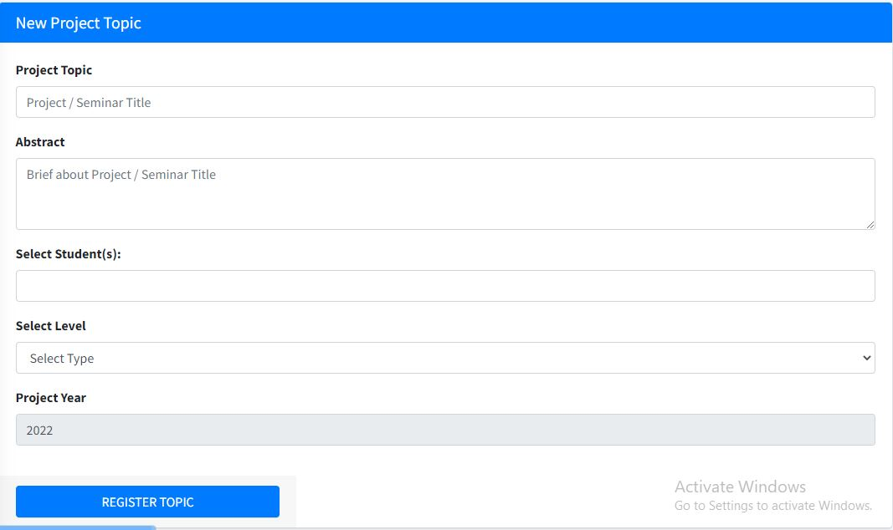

Figure 4.4: Register project topic

**4.2.5 Registered Project Topics**

This section displays a list of all project topics that have been registered within the system. It provides an organized view of assigned projects, allowing administrators and supervisors to track and monitor project allocations effectively.

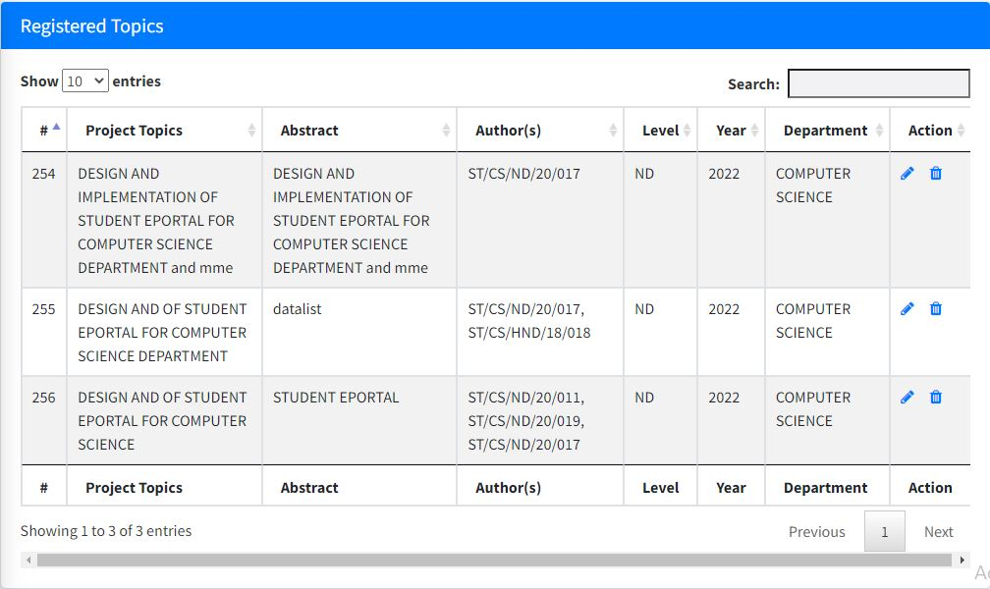

Figure 4.5: Registered project topics

**4.2.6 Registered Students Interface**

This interface presents a comprehensive list of all students who have been successfully registered in the system. It allows the administrator or project coordinator to review student records, confirm their eligibility for project submission, and ensure proper management of project allocations.

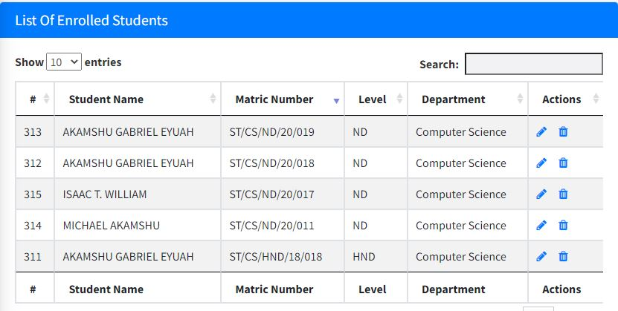

Figure 4.6: Registered Students Interface

## 4.3 Discussion

Welcome Interface: The Welcome Interface serves as the first screen that users encounter upon launching the system. It prominently displays the project title along with the names of the student(s) undertaking the project and the supervising lecturer. This interface provides an introductory view of the system, setting the context for users before they proceed to interact with its various functionalities, as shown in Figure 4.1.

Login Interface: The Login Interface is designed for authorized administrators to securely access the system. Existing admins must enter their credentials, such as a username and password, to gain access. This authentication process ensures that only authorized personnel can perform system operations, such as managing students, registering project topics, and overseeing the overall workflow, as shown in Figure 4.2.

Add Student Interface: The Add Student Interface allows administrators to register new students into the system. It includes input fields for essential details such as student names, registration numbers, department, and other relevant information. This interface ensures proper record-keeping and enables seamless student management within the system, as shown in Figure 4.3.

Register Project Topic Interface: The Register Project Topic Interface is specifically designed for project coordinators to input and register project topics submitted by students. This interface captures necessary details such as the project title, the student’s name, and possibly a brief description of the research scope. It helps maintain an organized database of approved project topics, as shown in Figure 4.4.

Registered Project Topics Interface: The Registered Project Topics Interface provides an overview of all project topics that have been officially recorded in the system. It displays key details, such as project titles and the corresponding students assigned to them. This feature enables administrators and project coordinators to easily track and manage project allocations, as shown in Figure 4.5.

Registered Students Interface: The Registered Students Interface presents a comprehensive list of all students who have been successfully added to the system. It typically includes relevant student details such as names, registration numbers, and departments. This interface allows administrators to view, manage, and verify student records efficiently, as shown in Figure 4.6.

## 4.4 User manual

## 4.4.1 System Installation

The user manual is a clear and precise instruction on how a user can operate the propose system, without any stress and successful. The following steps required

1. Start or boot the computer form the hard disk
2. Double click on the folder that program is been stored in the desktop
3. Double click on the program and allow it to load gently
4. A security unit will display were the user will specify the user name and password the click on OK.
5. A welcome menu will be displayed where the user has options to select which operation to be performed.
6. To find information about player, select any name and search.
7. Click on exist on the welcome screen to exist from the program.

## 4.4.2 System Operational Guide

The following are the necessary steps to take in order to use the system efficiently and effectively.

1. Load the url of the system <https://localhost/project/> the welcome page will be displayed.
2. Click on the **Proceed** button to proceed to the main system.
3. Provide the login details by entering your username and password.
4. The various task that you can perform on the portal will be displayed on the sidebar of the dashboard.

# CHAPTER FIVE

# SUMMARY, CONCLUSION AND RECOMMENDATIONS

## 5.1 Summary

The newly developed system has been designed to efficiently manage records related to project allocation and verification, specifically to monitor and prevent the duplication of project topics. All relevant data is stored in a well-structured database, allowing for seamless retrieval and manipulation of information. This ensures that the project coordinator can easily access and verify project topics, reducing redundancy and improving overall project management. The system effectively addresses key challenges that were previously encountered, such as inefficient record-keeping and lack of a structured verification process. By implementing enhanced security measures and a user-friendly interface, the system provides a reliable solution that meets the study's objectives while streamlining the process of project topic allocation and monitoring.

## ****5.2 Conclusion****

The design and implementation of the project allocation and verification system for monitoring the duplication of project topics have been successfully completed. The system ensures that project topics are uniquely assigned, eliminating the risk of repetition and ensuring better organization within academic project management. The objectives set at the beginning of the study were successfully achieved, demonstrating the system's effectiveness in addressing the identified challenges. By integrating an accessible and secure database structure, the system offers a practical and sustainable solution for project coordinators, ultimately improving the efficiency and accuracy of project allocation processes.

## 5.3 Recommendations

Based on the findings and successful implementation of this project, the researcher presents the following recommendations:

1. It is highly recommended that the department and school management integrate this automated project allocation and verification system into their administrative processes. By adopting this technology, the institution can significantly reduce the time-consuming procedures associated with the traditional manual system. The system will help streamline project allocation, minimize errors, and eliminate the duplication of project topics, thereby ensuring a more efficient and organized approach to project management.
2. To fully harness the benefits of this system, it is essential that all stakeholders, including project coordinators, supervisors, and students, actively and correctly utilize its features. Proper implementation and consistent use will ensure that the system operates at maximum efficiency, fulfilling its purpose of enhancing project topic verification and allocation. Regular training sessions and user awareness programs should also be conducted to ensure that all users are well-equipped to interact with the system effectively.
3. To ensure continuous and uninterrupted operation, the system should undergo regular maintenance and necessary updates. As technology evolves, periodic updates will help improve the system’s performance, security, and user experience. Additionally, scheduled maintenance should be performed to detect and resolve any technical issues before they affect users.